Work Insturction for 24171BBA01 Cutter Bearing

Modified Item: 625ZZ (16 mm OD,5 mm ID, 5 mm high shielded) roller bearing.

WARNING
Eye hazard. Bearing or grinder could come apart at any moment while rotating around 10,000 RPM.
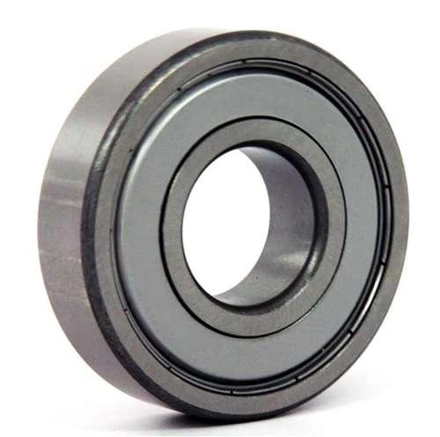
- Install grinding bit with flat face in spindle. Aluminum oxide or ceramic aluminum oxide preferred.
- Mount on CNC table into M5 threaded hole assembled in the following order, bottom to top:
  - standoff with 5 mm through hole ID (if necessary)
  - M5 washer
  - Bearing
  - M5 socket cap screw
- Tighten screw until bearing resists spinning. Loosen just until bearing is able to spin freely.
- Zero spindle at point where outer edge of grinder is 2 mm inside bearing outer edge and is bottom of grinder is just touching bearing.
- Start spindle and move downward by 0.01 mm steps until contact is made and bearing spins freely.
- Grind downward by 0.01 or 0.02 mm steps until chamfer is removed from bearing, about 0.4 mm. Check removal of chamfer with fingernail: bearing should shave nail when nail is scraped along bearing almost parallel to circumference.
- For final grind, grind without moving downward until contact between grinder and bearing is lost.

